**Name - Harshit Parsai**

**Registration no. - 11702448**

**Roll no. - 06**

**Section - KM054**

**Question Number - 06**

**Subject - INT305**

Informatica Data Integration (INT325)

Academic Task-2 - Report

Q6)

A) Create a mapping that performs the following operation using multiple transformations:

1.Display the countries whose sum of gold medals is more than 20

2.Display the countries who have won less than 10 medals till now

3.how many gold medal in swimming country wise

B)What is the difference between domain and node in informatica power center architecture?

Solution - >

For this solution in the coming pages i am attaching the snapshots and screenshots of the procedure and the practicals. I am explaining the procedure that we need to follow to do this question step wise step and then i will be putting the screenshots of the practical and the result of that as answer .

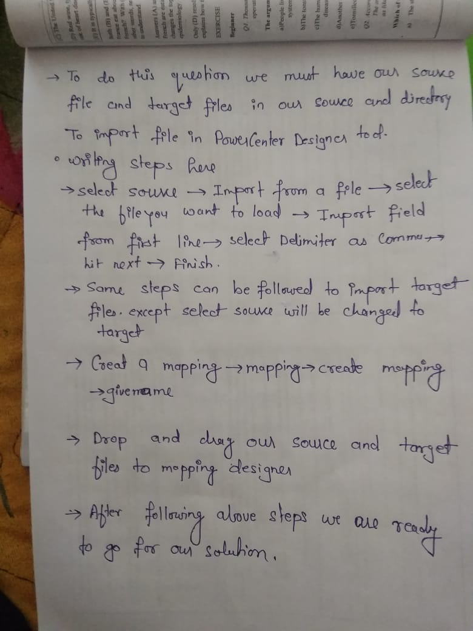

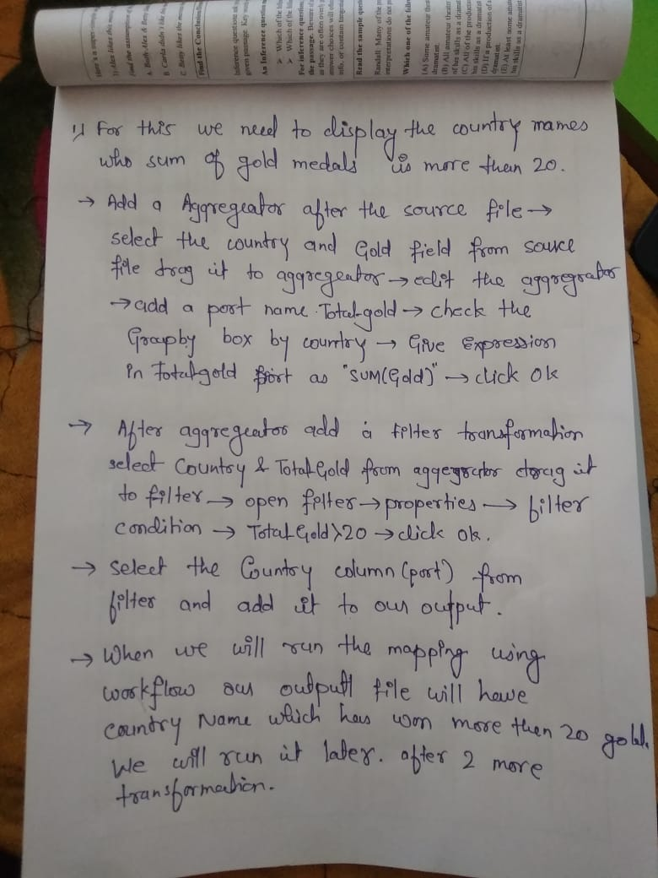

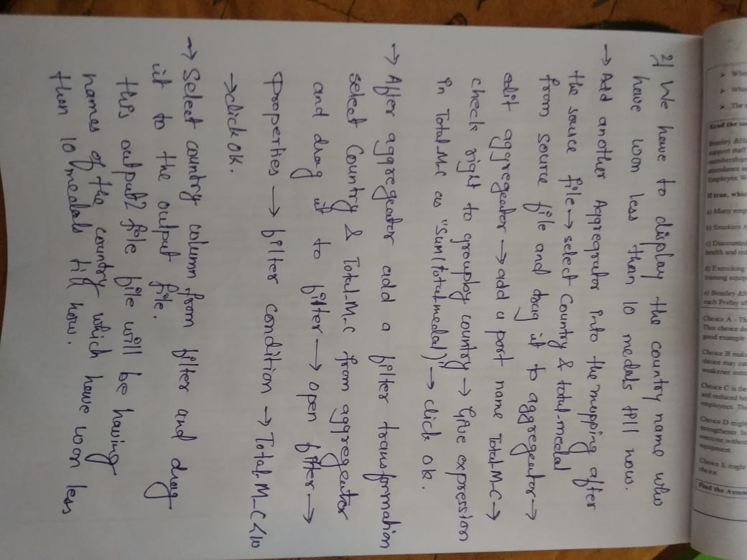



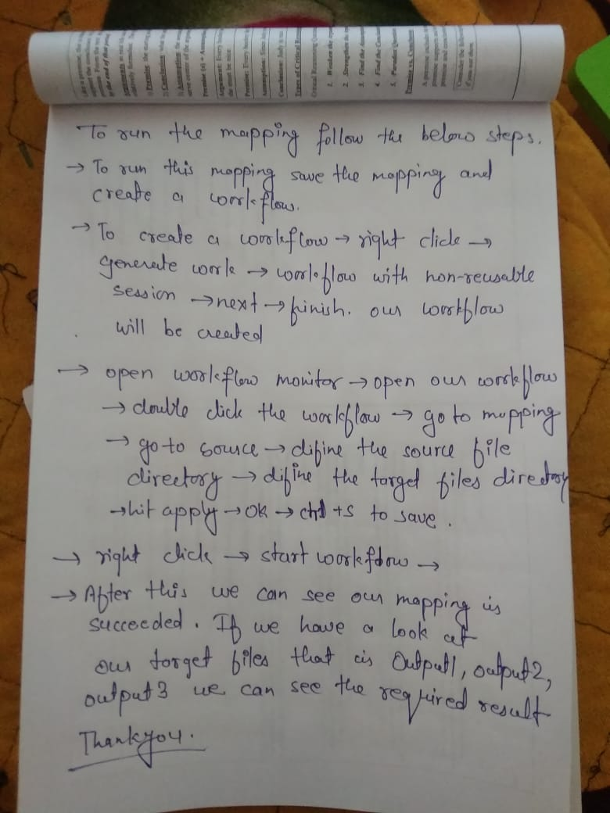

The Practical I have done in the developer And steps are written for Power Center->

Screenshot of the final mapping using the multiple transformation and filteration

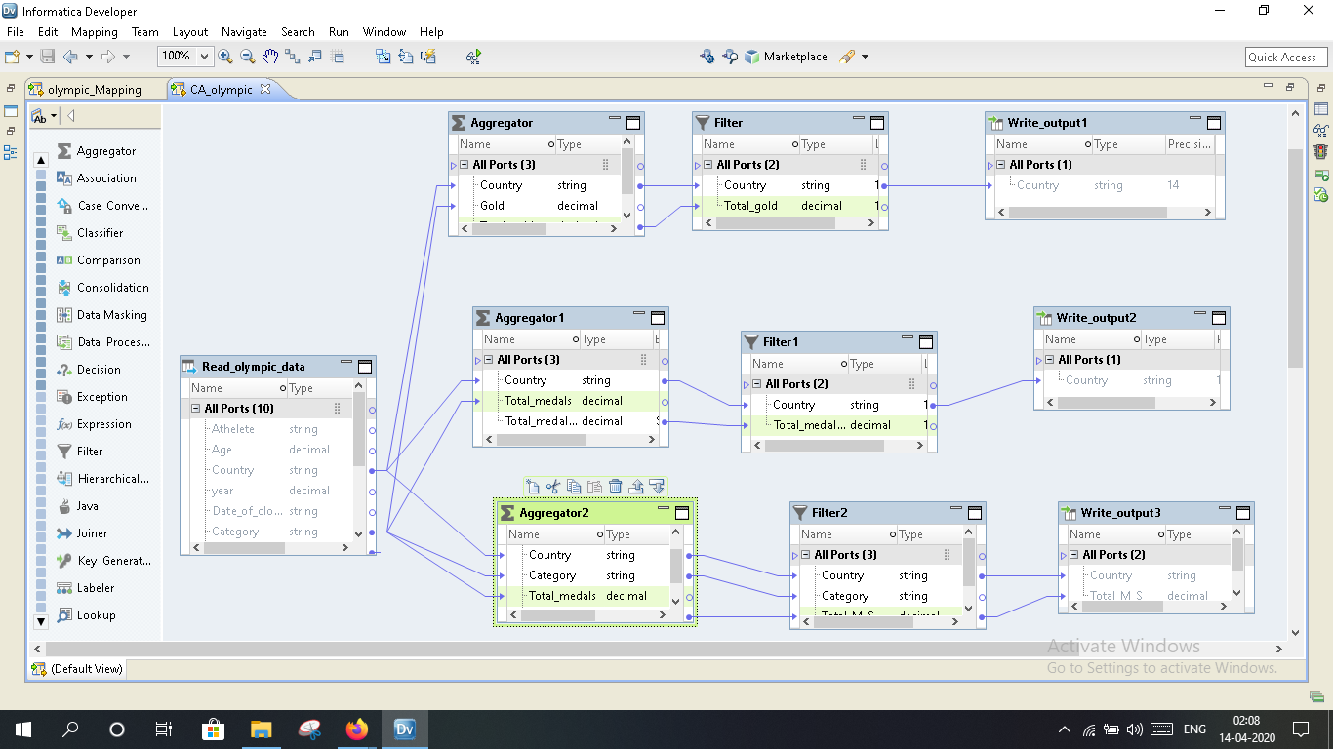

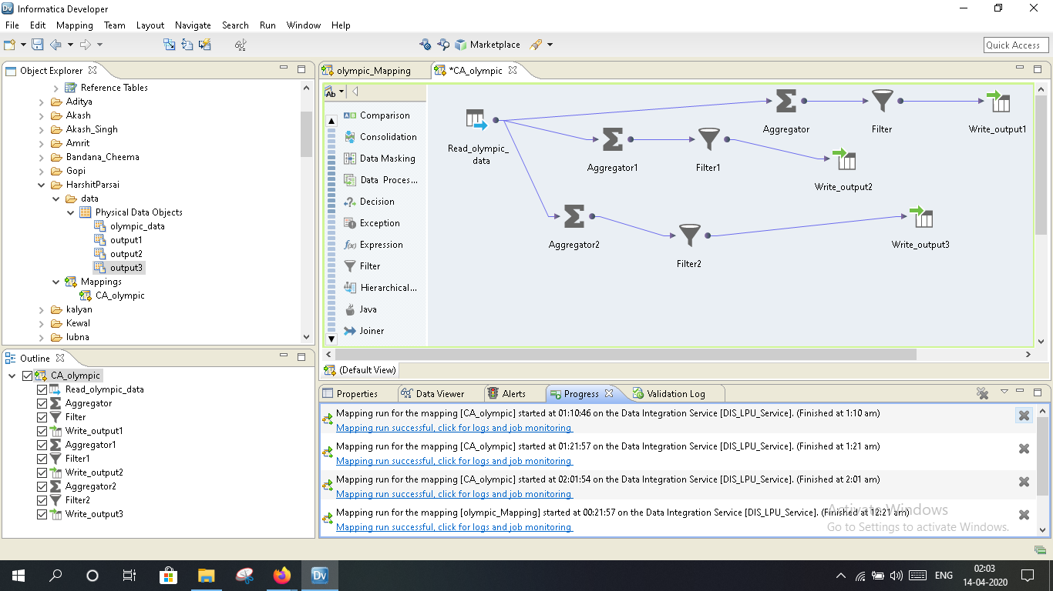

Screenshot of running the complete mapping that is made.

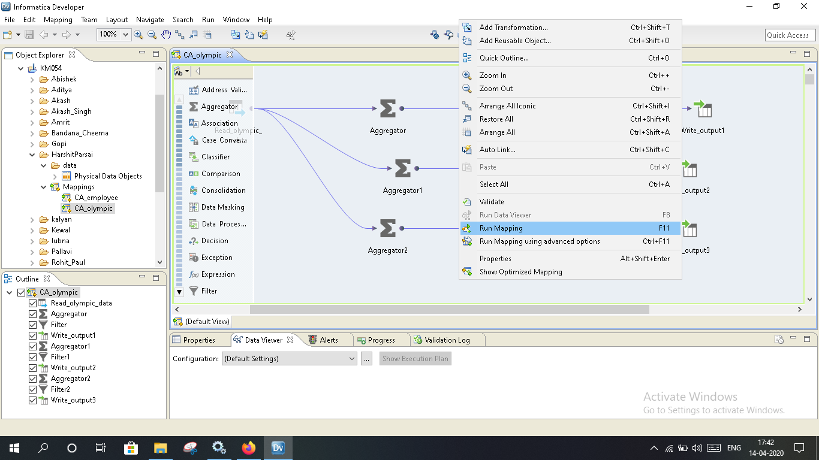

Screenshot of importing the files

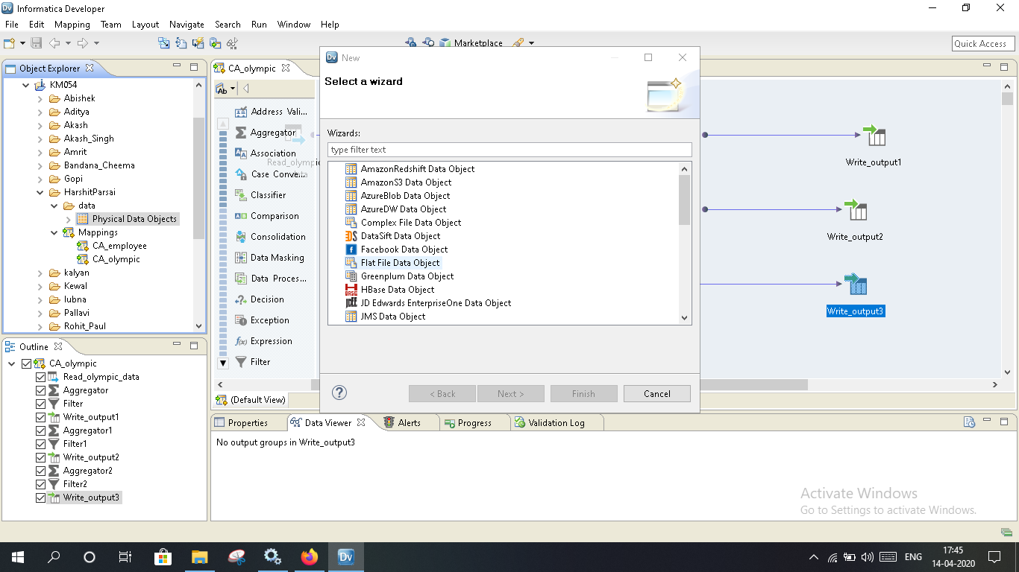

Screenshot of the Data in the source file

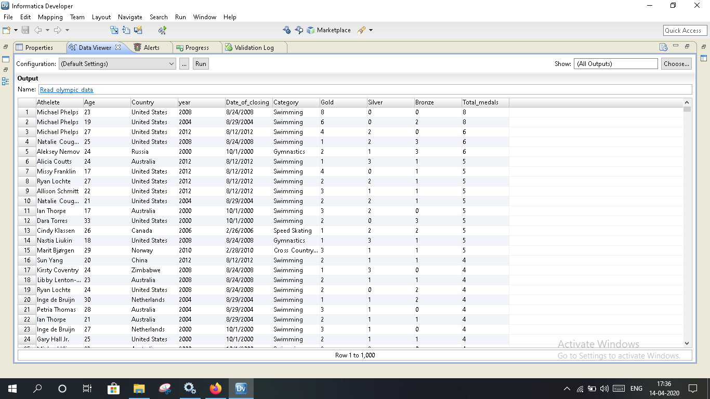

Screenshot of the first question mapping and transformation

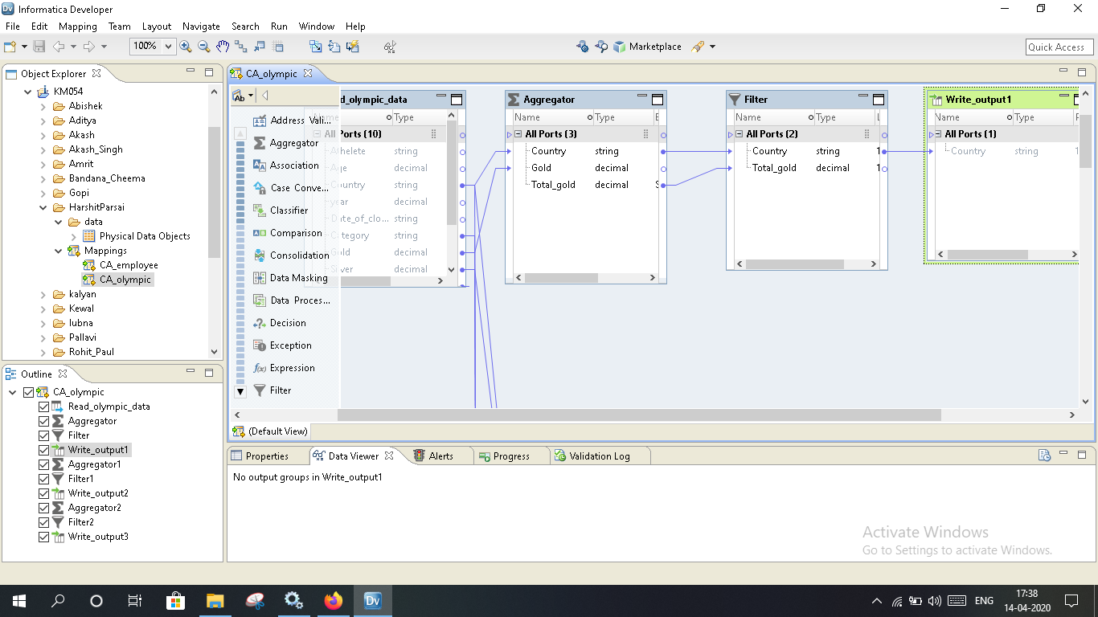

Screenshot of the result that we got after running the first question mapping and transformaiton : showing the countries who more than 10 gold medals

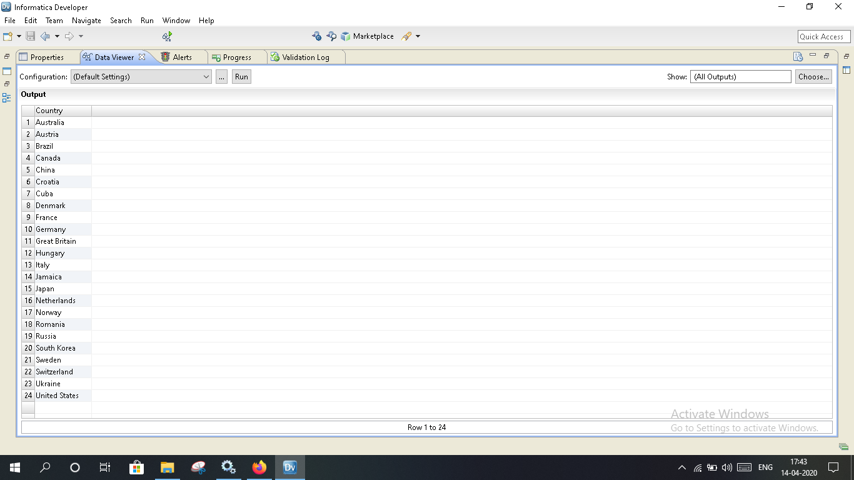

Screenshot of the mapping and the transformation of the second question

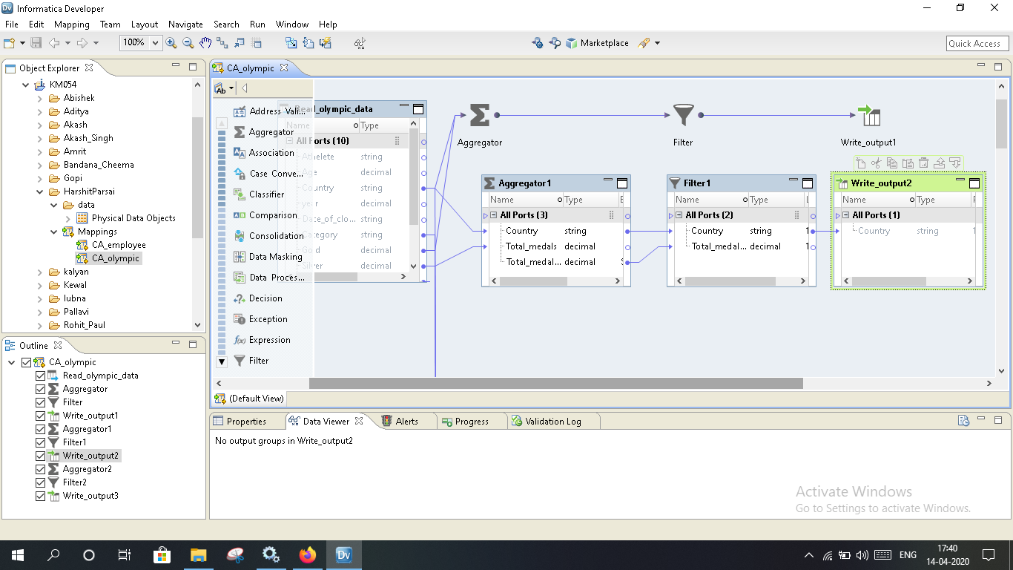

Screenshot of the result of the 2nd option in 1st question : showing the countries won less than 10 medals till now

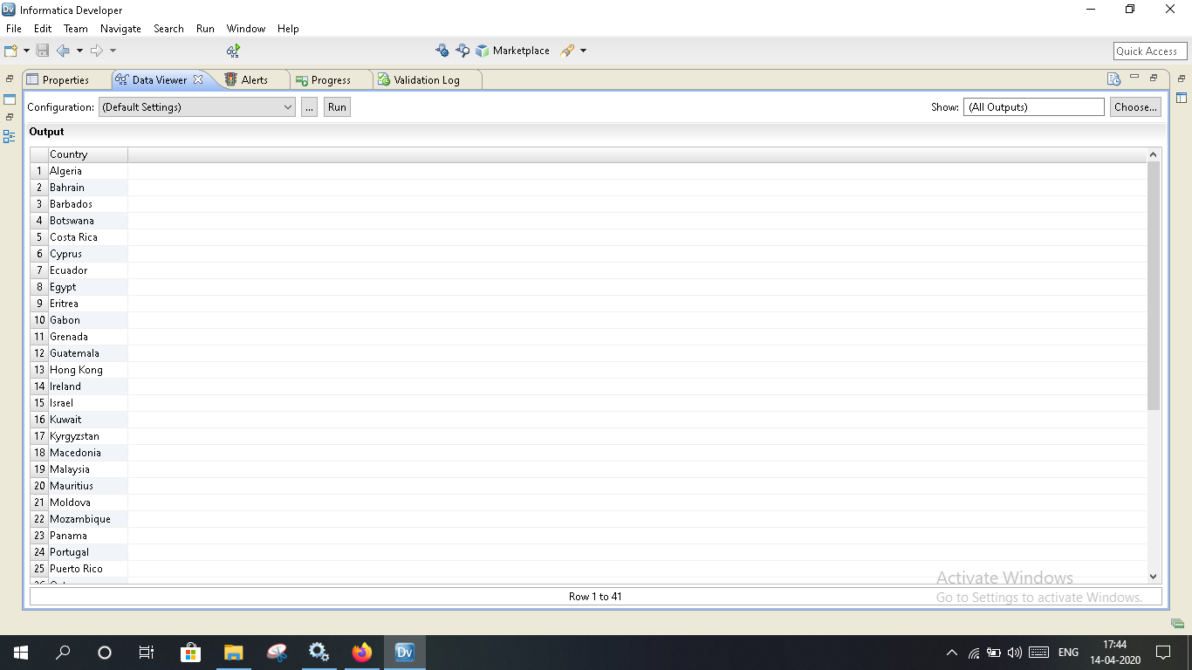

Screenshot of the result of the 3rd option of this question : showing the country wise gold medal in the swimming

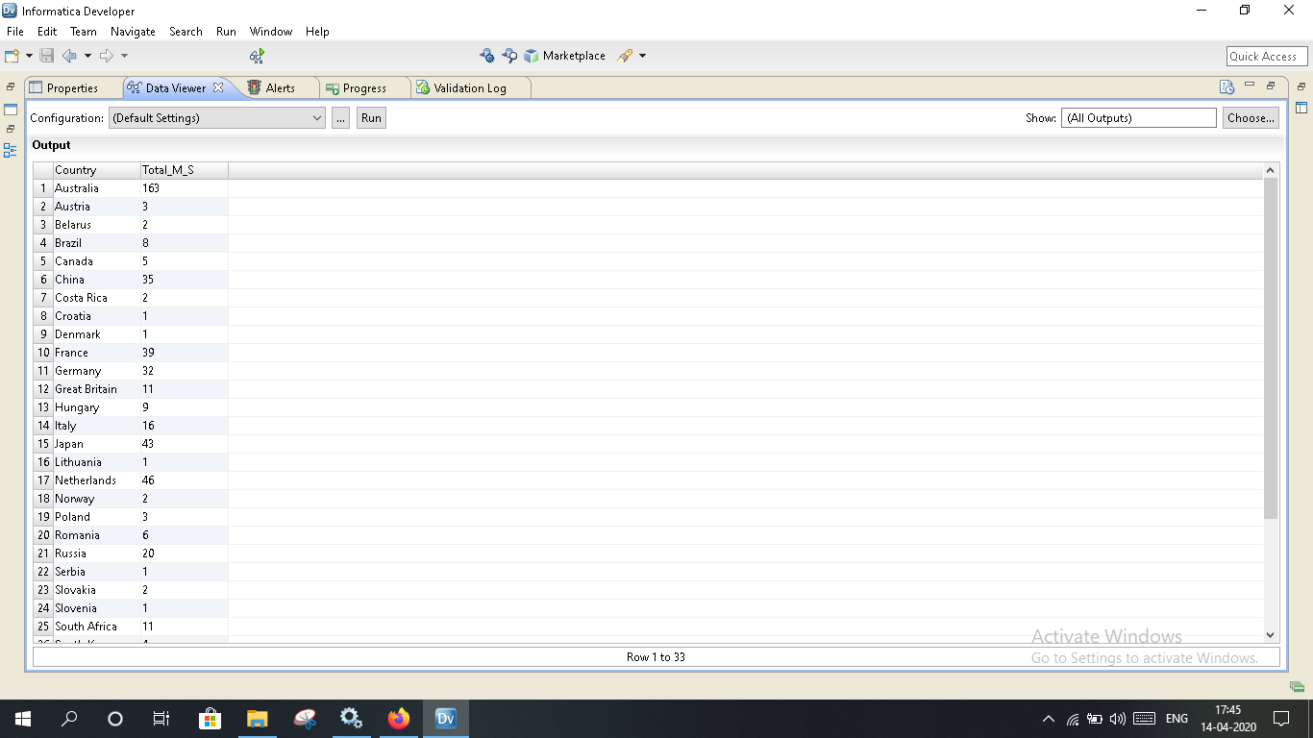

Solution B )

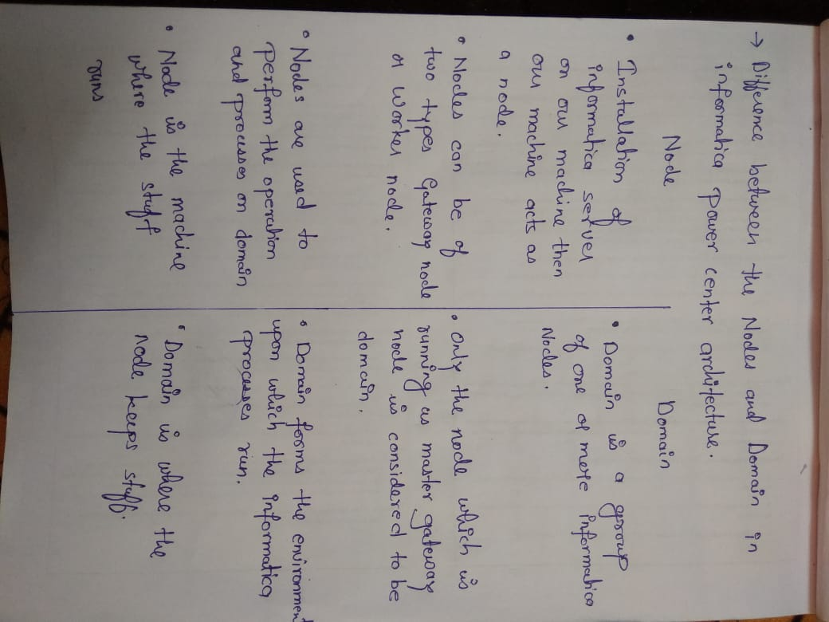

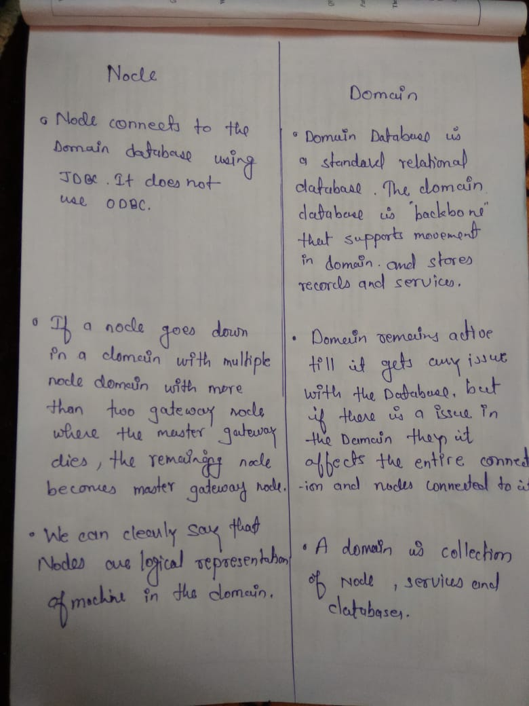

Best Picture demonstrating the domain and the node difference :-

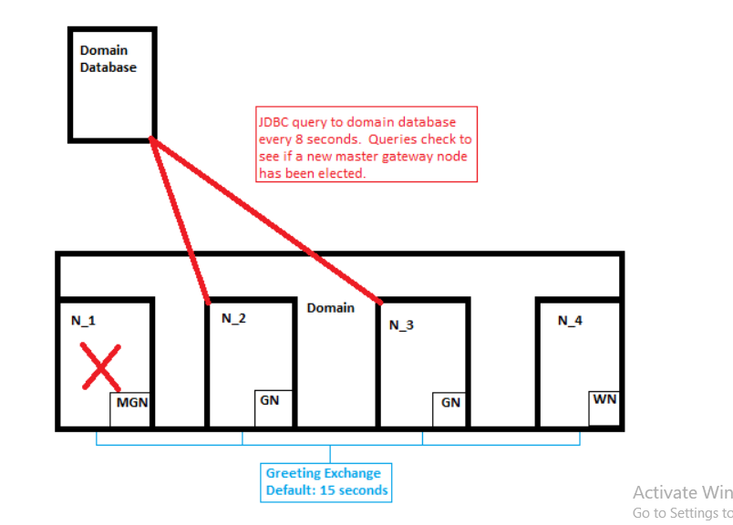

Thankyou.